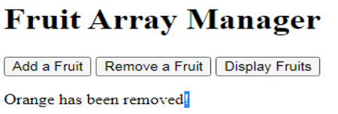
HTML Code
<!DOCTYPE html>
<html lang="en">
<head>
<meta charset="UTF-8">
<meta name="viewport" content="width=device-width, initial-scale=1.0">
<title>Fruit Array Manager</title>
<style>
body {
font-family: Arial, sans-serif;
background-color: #f0f0f0;
text-align: center;
margin-top: 50px;
}
h1 {
font-size: 2.5rem;
color: #333;
}
button {
padding: 10px 20px;
margin: 10px;
font-size: 1rem;
cursor: pointer;
background-color: #4CAF50;
color: white;
border: none;
border-radius: 5px;
}
button:hover {
background-color: #45a049;
}
p {
font-size: 1.25rem;
color: #333;
}
</style>
</head>
<body>

<h1>Fruit Array Manager</h1>

<button onclick="addFruit()">Add a Fruit</button>
<button onclick="removeFruit()">Remove a Fruit</button>
<button onclick="displayFruits()">Display Fruits</button>

<p id="message"></p>

<script>
let fruits = ['Apple', 'Banana', 'Orange'];

function addFruit() {
const newFruit = prompt("Enter the name of the fruit to add:");
if (newFruit) {
fruits.push(newFruit);
document.getElementById('message').textContent = `${newFruit} has been added!`;
}
}

function removeFruit() {
const removeFruit = prompt("Enter the name of the fruit to remove:");
const index = fruits.indexOf(removeFruit);
if (index > -1) {
fruits.splice(index, 1);
document.getElementById('message').textContent = `${removeFruit} has been removed!`;
} else {
document.getElementById('message').textContent = `${removeFruit} not found in the array.`;
}
}

function displayFruits() {
document.getElementById('message').textContent = `Fruits: ${fruits.join(', ')}`;
}
</script>

</body>
</html>

